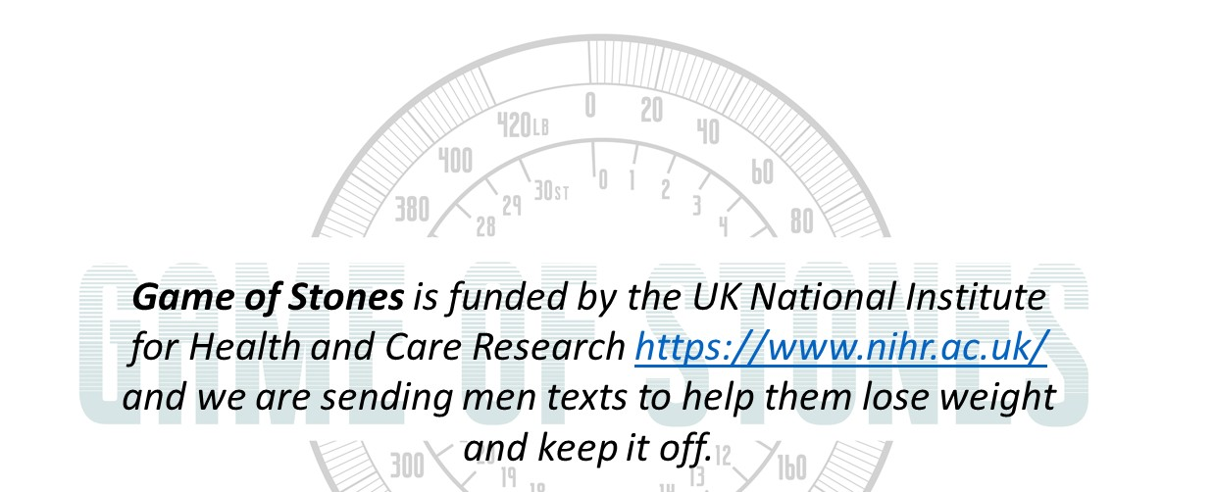
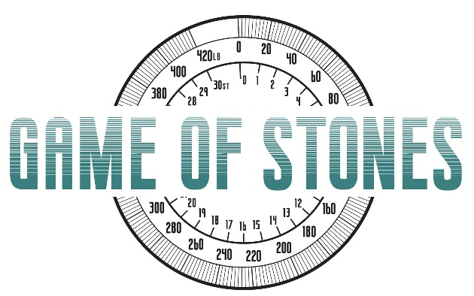

D E C E M B E R
Newslet2t0 2e2 r

Lucky 585!
You are one of our 585 participants - we had more men wanting to join than we had space for!
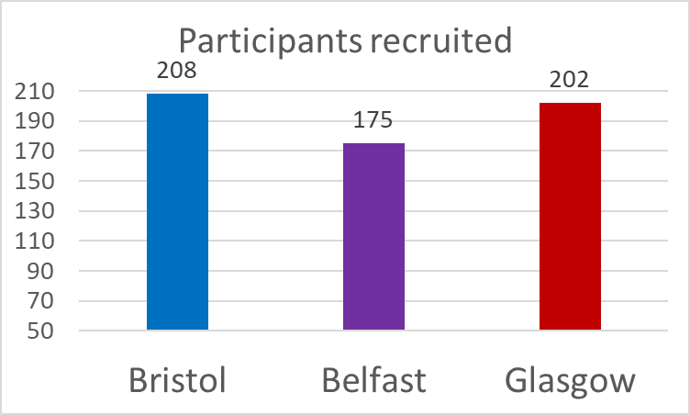
585 men joined Game of Stones over 11 months in 2021 / 22

WHAT WE'VE BEEN UP TO ...
Our Game of Stones researchers have been busy phoning, texting and emailing men to invite them to their follow-up appointments. We have had a fantastic response with many of you booking in, thank you! We've been asked some questions
about the importance of attending, see below:

Why is coming back so important?
We want to see all men no matter what has happened with your weight. It is very important for the quality of our research and to show whether the programme works. Remember there is a £20 voucher for coming to your 12 & 24 month visit.

What if I have not lost weight?
Don't worry. You are really important to the study because if we only see the men who have lost weight then it will make the programme look more effective than it actually is.

What if I have not been getting text messages?
Come back and see us! We need to see as many men as possible to get a clear idea of who lost weight over the past year. If you were in the 'control' group & come to your 12 month appointment, you will receive the text messages for 3 months.

I have less time / recently missed an appointment - can you help?
Yes! We will be flexible as possible and rearrange appointments, please chat to your local researcher. We can even arrange taxis or home visits.
Follow our progress on: www.gameofstonesresearch.com
Funded by NIHR Public Health Research [REF 129703]

Meet some of the team who are making the Game of Stones Trial possible.

Meet the Team

Clare & Christina are the Game of Stones researchers based in Queen's University Belfast. They have been seeing participants from across Northern Ireland. Please let them know if you have any special requirements to attend your appointment and they will try to help!
Clare Jess Christina O'Neill

Hilary & Jack are our research team from the University of Bristol. They are seeing participants at their university building in Clifton (with free parking!) or at your GP surgery if that's where you signed up. It's always worth having a chat with them if either of these options are difficult - they are very flexible!

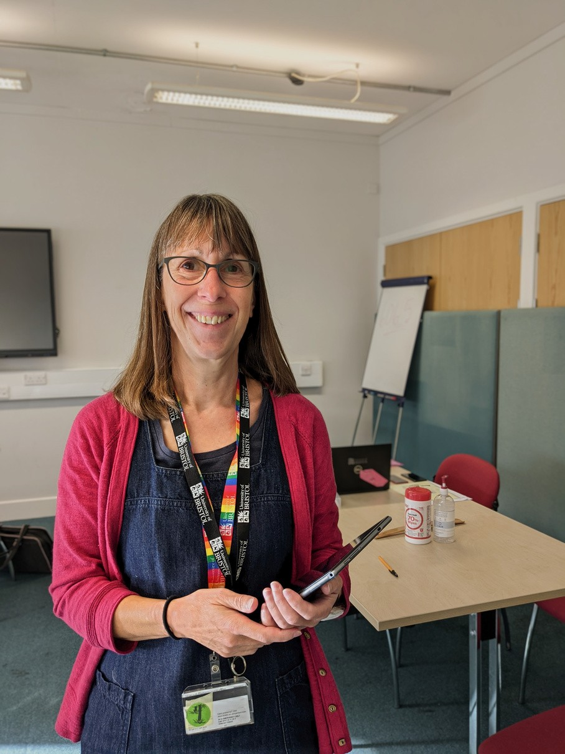
Hilary Taylor

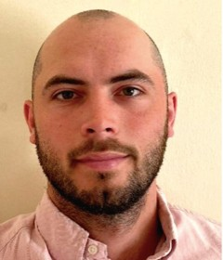
Jack Brazier

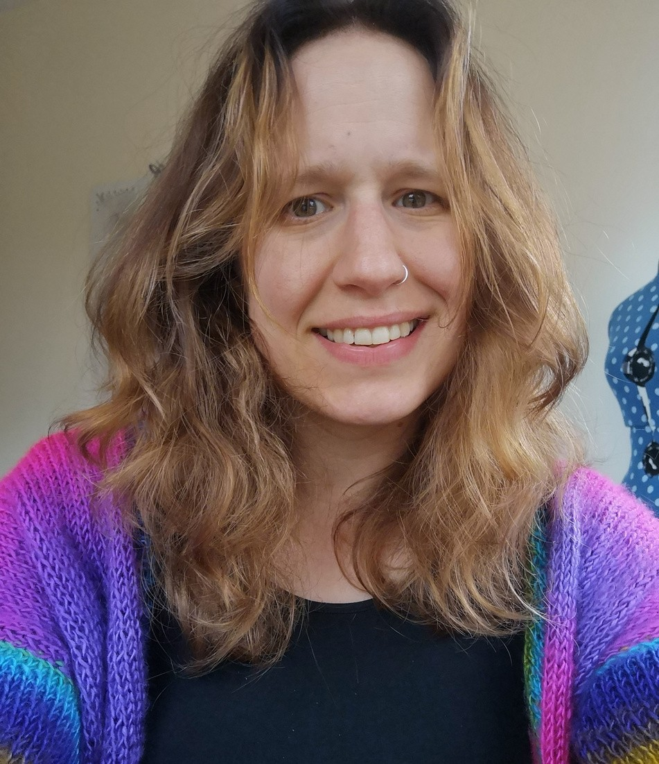
If you are one of our participants in Glasgow you will have met Claire or Kathryn from the University of Stirling. They see participants in venues across Glasgow which are all near bus/train stations or have nearby on street parking.

Claire Torrens
Norelle Calder_MacPhee
Kathryn Machray
Sadly, Kathryn has left the team to go travelling. We wish her well on her adventures and welcome Norelle who will be taking over some of her appointments.
From all of the Game of Stones team to all our participants.
We look forward to seeing you again in the New Year

Please note our universities are closed over Christmas & New Year so researchers may not be available until January.

