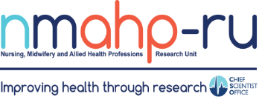
Newsletter

Volume 2, Issue 4. 31/01/21

In brief:
- Anne Whittaker and colleagues recently published a critical policy
analysis paper.
- The TOPSY team (based at GCU and UoS) have been successful in receiving a six month extension from NIHR to complete follow up which will continue until July 21. The study will now end 31/1/2022.

- Congratulations to Pat Hoddinott and Eddie Duncan who have been awarded CSO funding for a project to understand the lived experiences and support needs of people suffering from the long-term effects of COVID- 19.

Inside this issue:
Improving 1
Maternal Mental Health in South East Asia
New World Health 1
Organisation Global
Guidelines on Managing Children’s Chronic Pain
A note from our 2
Research
Partnership Group (RPG) Chairperson, Shelia Cameron
Improving Maternal Mental Health in South East Asia
By Prof Margaret Maxwell

Perinatal mental illness can have serious negative impacts on the wellbeing and welfare of women, their children and families. It has been suggested that prevalence of perinatal mental illness in low and middle income countries (LMIC) may be three times higher than in high income countries (HIC). Yet lack of knowledge, appropriate screening and diagnostic tools, and stigma, mean that perinatal mental illness is
under-reported and under- treated in many LMICs. A new study led by the NMAHP RU and funded by the MRC under the Seed funding Call -
of perinatal mental illness, and develop effective interventions via a network of culturally and ethnically diverse South East Asian countries with whom we have existing research links. Following a workshop in Kuala Lumpur in 2019 we prioritised the following activities for this award: (1) In preparation for a cross-cultural study of women’s experiences of perinatal mental illness and preferences for help seeking: Can we demonstrate a successful pilot of digital capture of women’s stories across partner regions? What types of women (age, ethnicity, religion) might require different approaches?
countries? (3) What adaptations are needed to deliver culturally appropriate and localised perinatal mental health awareness raising training for healthcare professionals and community workers?
What are the barriers and facilitators to future delivery and roll-out of awareness raising training across different sectors? We hope that the work to be undertaken over the next 12 months will provide a foundation for further studies in the region. We will also use the next 12 months to expand our networks, particularly the

Global Maternal and Neonatal (2) What is the predictive inclusion/participation of

Health 2019 has just commenced (January 2021) to address perinatal mental illness in South East Asia.
Our aim is to increase understanding and detection
validity and reliability of existing (translated) screening and assessment tools and are these relevant to the diverse cultural and ethnic contexts within and between partner
women and NGOs representing women’s health in the region.

New World Health Organisation Global Guidelines on Managing Children’s Chronic Pain
By Dr Emma France

Around 25% of children worldwide experience chronic pain and 5% have severe debilitating pain, yet there is a dearth of evidence to guide chronic pain management in children.
Recent research - a systematic literature review and synthesis of the qualitative research evidence - led by NMHAP- RU has directly informed the development of the new World Health Organization global guideline on managing children’s chronic pain. Dr Emma France led the research, which was carried out from March to
September 2020, to explore the views, perceptions and experiences of healthcare professionals and children with chronic pain and their families on the risks, benefits and acceptability of interventions for the management of chronic pain in children globally. The small team comprised Nicola Glennie, also of NMAHP- RU, Professor Jane Noyes of Bangor University and Dr Andrew Booth of the University of Sheffield in collaboration with Cochrane TaskForce and Cochrane
Pain, Palliative and
Supportive Care group. A
sister review led by Dr Emma Fisher of University of Bath was conducted investigating the effectiveness of pain management interventions for children. Dr France attended a week-long WHO guideline development group meeting of experts and observers in September 2020; the meeting, planned to take place at WHO Headquarters in Geneva, took place by video conference due to travel restrictions. The new WHO guideline was published in December 2020 and can be found here.

A note from our Research Partnership Group Chairperson, Shelia Cameron

My name is Sheila Cameron and I am the Chairperson of the Research Partnership Group (RPG). We are here to be a voice of various lived experiences that you can tap into when you feel we may be of benefit. Within the group there are patients, health care workers, carers and people with lived experience of an
extremely vast array of conditions.

Recent publications
As you can see from my
picture I have complex medical issues which require the assistance of carers (especially my 4 legged one!), Health Teams and supporters. I have lived experience of living with complex issues and various medical trials. I have spent over 40 years within various Educational and Research Teams, and I am currently doing a Masters in Online and Distance Education and a BA in Social Care alongside being a mother of one son.

I have lived and worked abroad, before returning to England to work for the Health and Safety Executive. I moved back to Scotland in 2009 after a severe accident that left me paraplegic. In the past 12 years I have been involved in various Research projects
within the Open University
looking at the effects of students Mental Health while studying remotely.

As RPG members we have already supported NMAHP-RU researchers in lots of different ways, from discussing emerging ideas to providing feedback on
funding proposals to even adopting roles as co-applicants.

The collective experience of our members is vast. There is never a wrong time to ask us ‘What do you think?’. As we develop as a group, we hope to provide support that can be accessed at ALL stages of your research journey, as often as required.

Patient Participation is evident within NMAHP. We need to make sure that every Grant Application has a strong PPI section. We are here waiting to help you to achieve that.

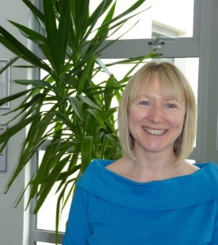
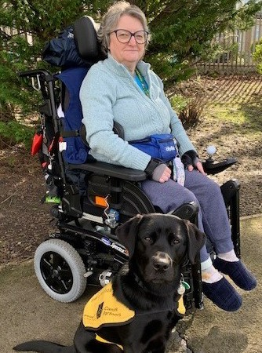
- Brown, S., Brady, M., Worrall, L. and Scobbie, L. (2021) A narrative review of communication accessibility for

In brief:
- Congratulations to Kris McGill and Kathryn
Vandenberg, who won the Verna Wright prizes for best oral presentation and best poster presentation across both Society for Rehabilitation Research (SRR) conferences (Nottingham and Warwick) held in 2019. Kris and Kathryn received their prizes virtually at the 2020 conference last November.
- What is the best way to
support resilience and
mental well-being in
frontline healthcare pro-
fessionals during and
after a pandemic? Click to listen to the podcast from the RECOVER team.

Find us on the web! www.nmahp-ru.ac.uk @NMAHPRu

Contact NMAHP-RU

GCU
nmahpruadmin@gcu.ac.uk 0141 331 8100
Govan Mbeki Building, Glasgow Caledonian University, Cowcaddens Road, Glasgow, G4 0BA

Stirling
nmahp.ru@stir.ac.uk 01786 466341
Pathfoot Building, University of Stirling, Stirling, FK9 4LA
people with aphasia and implications for multi-disciplinary goal setting after stroke. Aphasiology, 35 (1), pp. 1
-32.
- Dipper, L., Franklin, S., de Aguiar, V., Baumgaertner, A., Brady, M., Best, W., Bruehl, S., Denes, G., Godecke, E., Gil, M., Knoph, M., Kirmess, M., Markey, M., Meinzer, C., Mendez Orellana, M., Nouwens, F., Rose, M., van de Sandt Koenderman, WME., Whitworth, A. and Visch-Brink, E. (2021) An Umbrella Review of Aphasia Intervention descriPtion In Research: the AsPIRE project. Aphasiology (e-Pub Ahead of Print) Doi: 10.1080/02687038.2020.1852001.
- Evans, R., Moore, G., Movsisyan, A., Rehfuess, E., Arnold, A., Bishop, J., Booth, A., Copeland, L., Craig, P., Gardner, F., Hawe, P., Hoddinott, P., Kee, F., Littlecott, H., Moore, L., Murphy, S. and O’Cathain, A. (2021) How can we adapt complex population health interventions for new contexts? Progressing debates and research priorities. Journal of Epidemiology & Community Health, 75 (1), pp. 40-45.
- Watchman, K., Mattheys, K., McKernon, M., Strachan, H., Andreis, F. and Murdoch, J. (2021) A person- centred approach to implementation of psychosocial interventions with people who have an intellectual disability and dementia – A participatory action study. Journal of Applied Research in Intellectual Disabilities, 34 (1), pp. 164-177.
The full list of papers is available at https://www.nmahp-ru.ac.uk/research/publications/

Directors Blog:

The half of the NMAHP Research Unit based at University of Stirling is moving office location. However, as we are working remotely during the Covid-19 pandemic we do not yet have our new office address to share. We have adapted to remote working and ‘remote research’ to conduct the majority of the £25million worth of research that the Unit is
currently engaged in. We have revised our research methods to being on-line or telephone based (including surveys, focus groups, or interviews) alongside the usual desk-based systematic reviews or research using existing or secondary datasets. We have adapted several of our ‘intervention’ studies to enable their delivery on-line, which will have longer-term benefits for implementation and
reaching wider audiences beyond the research studies. As with the NHS, some of the changes we have had to incorporate as a result of Covid-19 will have a positive and sustainable legacy in terms of how we work and who we can reach.

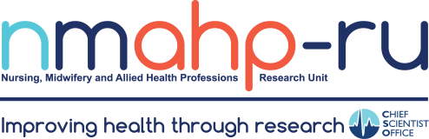
Best Wishes, Margaret Maxwell

