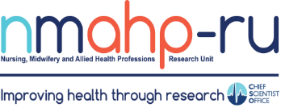
Newsletter
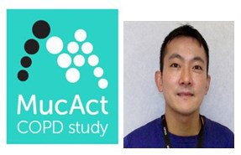
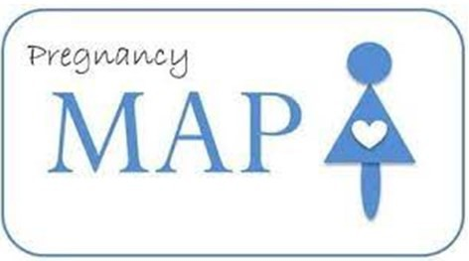

In brief:
- The MENTUPP project
will be holding an
interactive webinar
Volume 4, Issue 2. 30/04/22

The MAP Alliance study
By Andrea Sinesi

about barriers and facilitators to implementing workplace mental health promotion interventions on 25th May 2022, 9-10.30am.

- NMAHP-RU and Children in Scotland, on behalf of the Scotland’s National Suicide
Prevention Leadership Group (NSPLG), are to recruit, host and manage a new national Youth Advisory Group of twelve 16-25 year olds with lived
experience of suicidality to inform and improve policy from the perspective of those with lived experience. To find out more, click here.

- Mayara Silveira Bianchin has recently published a study calibrating accelerometry in children and adolescents with cystic fibrosis. Check it out here.

Inside this issue:
It is estimated that approximately 15% of women experience clinical symptoms of anxiety during pregnancy and in the early postnatal period. The MAP study,
funded by NIHR and
looking at the most
effective and acceptable method of assessing perinatal anxiety, completed recruitment in November 2021. The same team, led by Prof Susan Ayers at City, University of London and Prof Helen Cheyne at the NMAHP RU, and
including the NMAHP RU Unit Director Prof Margaret Maxwell and colleagues Dr Andrea

The MucAct Study

By Jason Tang

We are conducting a process evaluation within a trial (run by University of Edinburgh) of a new treatment that involves breathing in salty water through a nebuliser to help clear up phlegm (sputum) from the airways and reduce the number of chest infections in people with chronic obstructive pulmonary disease
The MAP Alliance study  By Andrea Sinesi | 1
The MucAct study  By Jason Tang | 1
A new partnership project to promote healthy weight and wellbeing in disadvantaged communities  By Julie Cowie | 2

(COPD).
The process evaluation aims to explore how participants are recruited into the trial, how it is delivered and what participants’ views are of taking part in the trial so that we can learn about what might help or hinder
Sinesi and Dr Cath Best, were delighted to receive further funding from the NIHR (£1,104,799.67) for
the MAP Alliance project.
This study will follow up the existing MAP cohort of over 2,000 women up
to 24 months after birth to
examine what care is
offered to and accessed by women with perinatal anxiety and associated disorders, and what the impact and cost of that

achieving the intended improvements in treatment for people with COPD. It also aims to understand both clinician and participants’ adherence and fidelity to implementation processes and how breathing in salty water and breathing exercises may help people with COPD feel better (if effective) and whether there are any people that
care is. Better understanding of care
pathways and inequalities in accessing treatment for women experiencing
mental health difficulties in the postnatal period will enable us to make recommendations about what is working and what can be improved to support women with perinatal anxiety.

this works for more than others.
We are observing how the trial is delivered in five clinical sites in the UK, interviewing key staff to find out what is working well and what might be improved, and speaking with trial participants to find out what they think of the treatment and taking part in the trial.

Partnership project with disadvantaged communities to design and test a novel evidence-informed and community-based intervention to address and promote healthy weight and wellbeing
By Julie Cowie

People living in disadvantaged areas seldom take part in weight loss services. Low income, unemployment, working anti- social hours and stressors like food insecurity make looking after health and wellbeing challenging.
Addressing the link between obesity and inequalities in people’s physical and mental health is a key priority for
citizens, Government and for post-Covid recovery. In partnership with two disadvantaged communities in Forth Valley, we will co- design a new community-led approach to incentivise,
support, and sustain healthy weight and wellbeing. We will review the current evidence on incentives with monetary value as motivators for
healthy weight and explore community preferences using a door-to-door citizen survey (online
option) and citizen involvement via pop-up cafés and social media to decide what would work best. The co-designed incentive intervention will be tested to see if it is helpful and can be delivered in a larger trial with linkage to future
health outcomes and long- term follow-up.

This work brings together researchers from across our two NMAHP-RU sites (Julie Cowie, Pat Hoddinott, Pauline Campbell, and Andy Elders) and other expert collaborators from Stirling and Aberdeen Universities, NHS Forth Valley and our 2 partnership communities.
The work will be supported by a research assistant and will commence in July 2022.

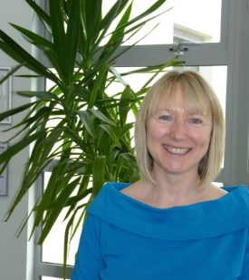

Find us on the web! www.nmahp-ru.ac.uk @NMAHPRu

Contact NMAHP-RU

GCU
nmahpruadmin@gcu.ac.uk 0141 331 8100
Govan Mbeki Building, Glasgow Caledonian University, Cowcaddens Road, Glasgow, G4 0BA

Stirling
nmahp.ru@stir.ac.uk 01786 466341
Pathfoot Building, University of Stirling, Stirling, FK9 4LA
Recent publications
Hazelton, C., McGill, K., Campbell, P., Pollock, A., Thomson, K., Nicolson, D., Cheyne, J., Chung, C., Dorris, L., Gillespie, D., Hunter, S. and Brady, M. (2022) Perceptual disorders after stroke: a scoping review of interventions. Stroke, 53 (5), pp. 1772-1787.

Sinesi, A., Cheyne, H., Maxwell, M. and O’Carroll, R. (2022) The Stirling Antenatal Anxiety Scale (SAAS): development and initial psychometric validation. Journal of Affective Disorders Reports (e
-Pub Ahead of Print), 8. Doi: 10.1016/j.jadr.2022.100333

Molina, G. and Whittaker, A. (2022) Treatment of post-traumatic stress disorder and substance use disorder in adults with a history of adverse childhood experiences: A systematic review of psychological interventions. Drug and Alcohol Dependence Reports, 2.

The RELEASE Collaborators., Brady, M., Ali, M., et al. (2022) Precision rehabilitation for aphasia by patient age, sex, aphasia severity, and time since stroke? A prespecified, systematic review based, individual participant data, network, subgroup meta-analysis. International Journal of
Stroke (e-pub ahead of print) Doi: 10.1177/17474930221097477

Directors Blog:
We recently submitted a report from the Unit to the CSO covering the period from our past Scientific Review (2017) to March 2022. Seeing progress is always a great thing, but even I can be taken aback by the achievements of the NMAHP RU when they are pulled together. In 2017 the value of our portfolio of research was £21 million, as of April 2022 the current value now stands at £34.3 million. Just over £7.6 million of this has been awarded (to us and
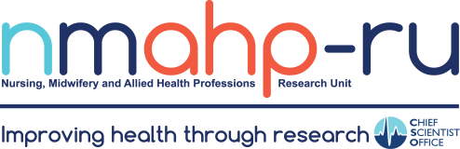
or collaborators) in the past year. To date, the Unit has been involved in 12 Covid-related research studies. Since our last review we have developed significant new international collaborations (Sub-Saharan Africa, South East Asia, the South Pacific) alongside several other individual projects often involving more than 40 countries. In terms of impact, the Unit contributed to 5 Impact case studies submitted under Unit of Assessment 3: Allied Health Professions, Dentistry, Nursing and Pharmacy to the REF2021. Our staff numbers continue to increase, mainly in the number of externally funded (contract) research staff which has increased from 24 in 2017 to 31 (end of March 2022) leading to a current overall total of 50 Unit staff. Since 2017 we have supported 20 PhD students and Clinical Doctorate students to completion. We currently support 34 PhD and Clinical Doctorate students. These are just some of our incredible achievements that make me a very proud Director.

Best Wishes, Margaret Maxwell

