Newsletter
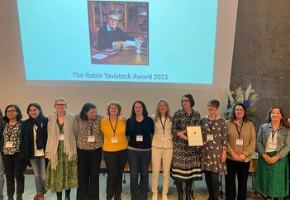

In brief:
Dr Lynne Gilmour and Louise Honeybul, in collaboration with Children in Scotland and Scottish Ensemble have
Volume 5, Issue 2. 31/07/23

NESSIE
By Alex Todhunter-Brown

completed the first two of three innovation labs in Stirling and Inverness as part of the Live Music for Mental Health project. The labs aim to co-design fun live music events which benefit young people’s mental health and bring
together children and young people, support workers and mental health practitioners, and musicians to develop
their skills and confidence in sharing and listening to ideas.
NESSIE has set sail within NMAHP-RU! NESSIE
(NIHR Evidence Synthesis Scotland InitiativE) is one of nine new evidence
synthesis groups commissioned by NIHR (National Institute for Health and Care Research). The aim of these new NIHR evidence synthesis groups is to address knowledge gaps within healthcare, public health and social care. NESSIE will
receive £2.5million funding over 5 years, supporting a team who will conduct reviews of research evidence that NIHR considers high priority for making decisions about health and social care policies.
Professor Alex Todhunter- Brown, who is co-leading NESSIE, said: “This award recognises NMAHP-RU’s expertise in conducting evidence syntheses relating to health and social
care. Partnering with University of Edinburgh strengthened our bid, combining the more medical, epidemiological
and statistical strengths of the Usher Institute in
Edinburgh, with our expertise in health and social care, mixed method reviews, and patient and public involvement.” Other NMAHP-RU staff involved include Emma France,
Pauline Campbell, Katie Thomson, Bridget Davis and Ceri Sellers.
More about NESSIE is available here: https://
www.ed.ac.uk/usher/nessie

Good news for CATs! By Jaclyn McArthur

Inside this issue:
The Collaboration of Aphasia
NESSIE  By Alex Todhunter- Brown | 1
Good news for CATs!  By Jaclyn McArthur | 1
CSO Fellowship  focused on retention in midwifery  By Gill Moncrieff | 2

Trialists (CATs) has been awarded another two years of funding to support its research aimed at improving
the lives of stroke survivors with speech problems. In addition to this great news, the CATs group were presented with the Robin
Tavistock Award 2023 during the CATs event held in
Iceland in June.
The Award is presented annually to an individual or group, who is inspirational and who has made a
significant contribution in the field of aphasia.
Professor Marian Brady said: "As recipients of the
international Robin Tavistock Award we are honoured that our efforts to improve the quality, effectiveness and reporting of aphasia research
have resonated with the Trustees and recognised in a global context.
Professor Brady is stepping down as Chair of CATs from January 2024 and she is delighted to announce the
joint-appointment of
Professors Madeline Cruice [GB] and Lucy Dipper [GB] (both from City University of London) to the role of CATs Chair. They will formally take up their shared role from
February 2024 which also marks the transition to the new CATs funding award
from the Tavistock Trust for Aphasia, UK which runs until January 2026.
Marian said: "With another two years of funding announced and the new incoming Chairs with fresh ideas and ambitions, the
future is bright for CATs! With
an ever-growing membership and ever-increasing collaborative effort, we have brought highly ambitious research projects within reach, and there is much more to come."

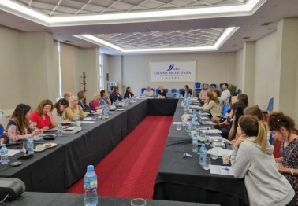
CSO Fellowship focused on retention in midwifery

Prof. Margaret Maxwell was in Albania recently catching up on the EU MENTUPP
study (promoting mental health in the workplace) and its trial in over 60 small to medium enterprises in 9
European countries. The trial is just in its final 9 month
follow up period so we expect results to be available soon.

Find us on the web! www.nmahp-ru.ac.uk @NMAHPRu

Contact NMAHP-RU

GCU
nmahpruadmin@gcu.ac.uk 0141 331 8100
Govan Mbeki Building, Glasgow Caledonian University, Cowcaddens Road, Glasgow, G4 0BA

Stirling
nmahp.ru@stir.ac.uk 01786 466341
Pathfoot Building, University of Stirling, Stirling, FK9 4LA

By Gill Moncrieff

Gill Moncrieff has been awarded a CSO Fellowship focused on retention in
midwifery, with Helen Cheyne and Margaret Maxwell. As a clinical academic fellowship, Gill will also be working closely with NHS Lothian.
The focus of the Fellowship is the development of a retention strategy for midwives, based on the factors that influence
retention and attrition in midwifery. It is envisaged that this will be highly valuable due to the high leavers rates in midwifery, and the
influence this is having on workloads and mental health for staff, and safety for service users.

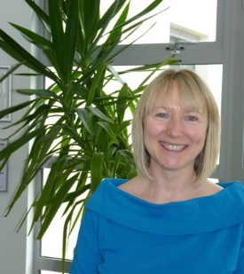

Recent publications
- Corbetta, D., Campbell, P., van Wijck, F., Filippi, M., Kwakkel, G., Lynch, E.A., Mehrholz, J. and Todhunter-Brown, A. (2023) Interventions for improving walking after stroke: an overview of Cochrane Reviews (Protocol). Cochrane Database of Systematic Reviews, (Issue 3, Art. No.: CD015044).
- Graham, M. and Goodman, K. (2023) Commentary on my personal experience of Patient and Public Involvement in the TOPSY Trial. Trials, 24 (1), pp. 228.
- Harkness, M., Yuill, C., Cheyne, H., McCourt, C., Black, M., Pasupathy, D., Sanders, J., Wallace, C., Heera-Shergill, N. and Stock, S. (2023) Experience of induction of labour: a cross- sectional postnatal survey of women at UK maternity units. BMJ Open, 13 (5), pp. e071703.
- Pilic, A., Reda, S., Jo, C.L., Burchett, H., Bastías, M., Campbell, P., Gamage, D., Henaff, L., Kagina, B., Kulper-Schiek, W., Lunny, C., Marti, M., Muloiwa, R., Pieper, D., Thomas, J.C., Tunis, M., Younger, Z., Wichmann, O. and Harder, T. (2023) Use of existing systematic reviews for the development of evidence-based vaccination recommendations: guidance from the SYSVAC expert panel 9. Vaccine, 41 (12), pp. 1968-1978.
- Tsantila, F., Coppens, E., De Witte, H., Abdulla, K., Amann, B.L., Arensman, E., Aust, B., Creswell-Smith, J., D'Alessandro, L., De Winter, L., Doukani, A., Fanaj, N., Greiner, B., Griffin, E., Leduc, C., Maxwell, M., Connor, C.O., Paterson, C., Purebl, G., Reich, H., Ross, V., Van Weeghel, J. and Van Audenhove, C. (2023) Developing a framework for evaluation: a Theory of Change for complex workplace mental health interventions. BMC Public Health, 23 (1), pp. 1171.
- Yuill, C., Harkness, M., Wallace, C., Cheyne, H., Black, M., Modi, N., Pasupathy, D., Sanders, J., Stock, S. and McCourt, C. (2023) Clinicians’ perspectives and experiences of providing cervical ripening at home or in-hospital in the United Kingdom. PLOS 1, 18 (5), pp. e0284818

Directors Blog:
In the previous (April 2023) newsletter I spoke of the Unit’s approach for seeking new funding streams. Since then, there have been some
national announcements which bode well for our strategy. There has been some news in relation to EU Horizon funding and interim arrangements while the EU is in the process of formalising the UK’s association to Horizon Europe. In June, it was announced that the UK
government would extend its guarantee that successful Horizon Europe applicants will receive funding regardless of the outcome of the UK’s efforts to associate with Horizon
Europe. This extension applies to all Horizon Europe competitions with a final deadline date on or before 30 September 2023; which is great news for the NMAHP-RU as we are currently a partner in 2 Horizon Europe bids (one on promoting physical and mental health in the workplace (PROSPERH) and another on addressing mental health needs in primary care workers (PRIMA-WELL). Another fantastic announcement is that from this Autumn researchers in Scotland (and other devolved nations and some small to medium enterprises) will now have access to five further NIHR research programmes: Evidence Synthesis;
Invention for Innovation (i4i); Research for Social Care (RfSC); Programme Grants for
Applied Research programme (PGfAR); Programme Development Grants. This is indeed significant for our Unit, particularly the access to programme grants as sticking with a
problem across a series of projects to achieve impact has long been our strategy within the workstreams we adopt.

Best Wishes, Margaret Maxwell

