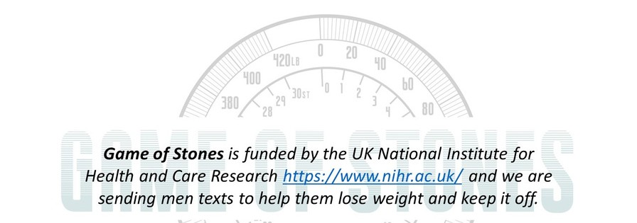
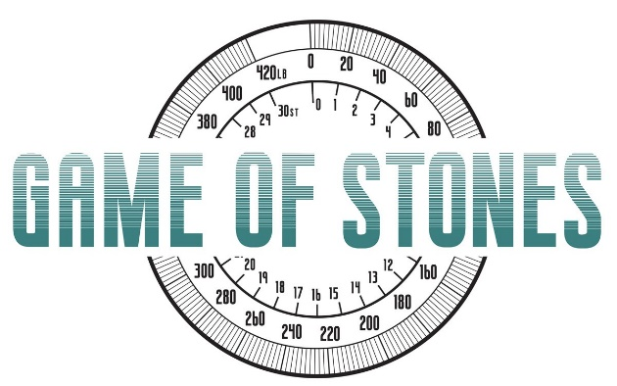

M A R C H 2 0 2 3
Newsletter
Welcome!
To the Game of Stones Spring Newsletter.
We are almost halfway though the study already!

What we've been up to...

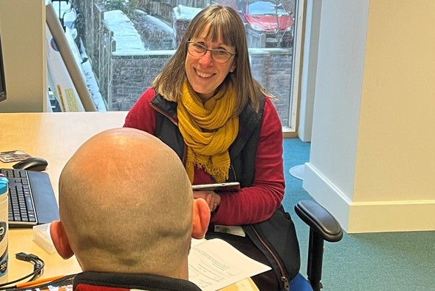
All 3 & 6 month follow-up appointments are complete! It's great to have had so many men come back and see us. Each & every one of you is important for the final study results. Our researchers are busy contacting men for their 12 month follow-ups. Find out why your views and the information you provide at 12 months matters on the back of this newsletter.
Remember...
All results are important, even if you haven't reached the weight targets you were aiming for.
You are contributing to research that other men & health professionals tell us is really valuable.
Get in touch if we can make coming to appointments easier for you.
You get a £20 voucher for coming back to see us!
Game of Stones follow up appointment, Bristol

What happens next?

All participants will be followed up 2 years
after they first joined Game of Stones. For our first recruits who joined us in July 2021, there's not long to go! The team are now planning for the final follow-up phase that will take place between July 2023 and June 2024. At the same time we will begin analysing the data we have collected so far. This will be done by a team of statisticians based at the Centre for Healthcare Randomised Trials at the University of Aberdeen. All data is kept anonymous during this process.
When will I hear about the results?
The results of the first year of the trial will be published on our website: www.gameofstonesrearch.com in 2024.
Follow our progress on: www.gameofstonesresearch.com
Funded by NIHR Public Health Research [REF 129703]

What is a Randomised Controlled Trial (RCT) and why is my data so important?
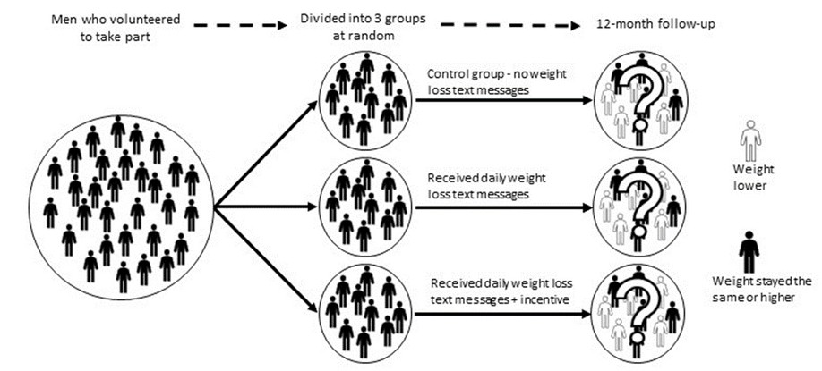
You're amazing!
Thanks for volunteering to be a part of our research study. Here you can learn more about the design of the study, why the data that we are currently collecting is so important, and how to share your views about Game of Stones.

Why were we divided into three groups in the study?
Game of Stones is a randomised controlled trial (RCT). This is considered to be the ‘gold standard’ in healthcare research. A RCT is a particular study design that involves dividing participants into groups at random (like tossing a coin). There are groups that receive the treatment being tested and a 'Control' that doesn't receive the treatment. The Control group is essential as this allows us to measure whether the treatment has made a difference.

Why is the 12-month follow-up so important?
The time-point at which the data is collected to decide the outcome of an RCT is called the ‘primary endpoint’. For Game of Stones this is collected at the 12-month follow-up. It is the most important data in the trial as it will tell us whether the text messages or incentives made a difference for men who want to lose weight.

Why is it so important to collect data from as many men as possible?
We need to collect 12-month data from as many of the men in the study as possible so that we have enough evidence to say with confidence whether the text messages helped more men to lose weight or not. This means we need to see men who received the text messages and those who didn’t, and men who lost weight as well as those who did not. Every man counts!

What do you expect to find?
We expect to find that there will be men who lost weight, gained weight, and men whose weight stayed the same in all 3 groups. We want to see which groups lose more weight and whether we have a scientifically tested method that can be used to support men who want to lose weight in the future.

Let us know what you think!
We are conducting interviews with some men to find out what they thought about Game of
Stones. We would love to hear from any men who took part in the trial. You can leave your feedback on the last section of the questionnaire or drop us an email at gameofstones@stir.ac.uk. All answers will be treated anonymously!

