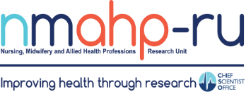
Newsletter

Volume 2, Issue 1. 31/01/2020
In brief:
- Congratulations to Dr David MacDonald on being awarded the Member of the Order of the British Empire MBE for his services to health care. David, a senior research
fellow at NMAHP – RU is also national lead for Enhanced Recovery across NHS Scotland, a program of work he began at the
Golden Jubillee
Hospital.

- Well done to Alex Pollock, Kirsteen Goodman, and Ciara Ryan who were nominated for the GCU (Glasgow Caledonian
University) Points of pride event for their work establishing
the unit’s Research Partnership Group (PPI).

- Recruitment targets have now been reached ahead of schedule for
START-UP and
TOPSY. Great work by the trials teams!

Behavioural Intervention to increase CPR Performance
by Dr Barbra Farquharson

Barbara Farquharson and the BICeP study team have been busy with all
things CPR. Their CSO- funded Systematic Review exploring the psychological and behavioural factors related to whether or not people attempt CPR is almost complete and will soon be submitted for publication.
Their work has already led to an MRC PHIND (Public Health Intervention Development) grant funded by the Medical Research Council, a project which aims to develop a text-message behaviour change intervention to improve lay
-people’s confidence and willingness to perform CPR. Claire Torrens

(BICeP research fellow) will be conducting focus groups over the next couple of months with people who have had CPR training to find out what they think would be appealing and engaging to include in the
text messages. The team will then work closely with their talented expert advisory group, creatives and lay-people to develop around 36 behaviour change messages to send to people in the weeks following CPR training. A pilot study towards the end
of the year will explore what people made of them.
Barbara and her BICeP collaborator (Prof) Diane Dixon (Uni of Aberdeen) were also recently awarded a CSO Catalytic Grant to

conduct a Systematic Review of the CPR
instructions emergency service staff provide.
They hope all this work will improve rates of CPR when people collapse suddenly, when every second can make the difference.
If you are interested in the psychological
aspects of CPR or would like to know more about this work they would love to hear from you: Bf19@stir.ac.uk

IdentifyiNg and assessing different approaches to DEveloping compleX interventions (INDEX) by Dr Pat Hoddinott

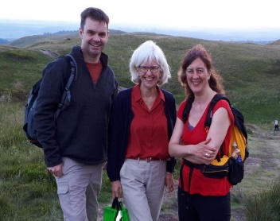

Inside this issue:

2019 was a very productive year for the INDEX team, with 5 papers published - available on the INDEX website https://
1
INDEX
1
BICeP
www.sheffield.ac.uk/
scharr/sections/hsr/mcru/
indexstudy, several well attended talks and a QUESTS research methods webinar on intervention design
2
ICTMC2019
https://quests.ie/
qualitative-research-
intervention-development
-index-study/
IdentifyiNg and assessing different approaches to DEveloping compleX interventions (INDEX) was funded by the Medical Research Council to fill an important methodological gap on how to do intervention development. The Study was led by Alicia O’Cathain, University of Sheffield with Co-
Investigators in Bristol, Southampton and three NMAHP-RU staff in the team at Stirling. The qualitative research was
led by Pat Hoddinott and Eddie Duncan led the e- Delphi study to reach consensus for the final
INDEX guidance.
Congratulations to Research Fellow Nikki Rousseau, who worked with Pat and Eddie, and has been awarded a Healthcare Technology Evaluation Fellowship at the University of Leeds.
The main guidance paper and a qualitative paper on how to develop successful interventions are published in BMJ Open. A second qualitative paper exploring more creative aspects of design is published in PloS ONE. Eddie has led the guidance paper on how to report intervention development studies which is coming soon and will help us learn more about what works and doesn’t.

5th International Clinical Trials Methodology Conference
by Dr Kirtseen Goodman

Reflecting the large number of clinical trials currently underway in the Unit, we had a significant presence at the ICTMC in
Brighton from the 6th to the 9th October 2019. Kirsteen Goodman, a senior trial manager provided us with a summary of her involvement in the conference.
“As a trial manager this is one of my favourite conferences, not only for the content but for the ability to meet up with so many of my peers from past and present projects. For this conference, I had 2 abstracts accepted for an oral
presentation. First I co- presented with Anne Duncan
(Health Services Research Unit, Aberdeen) on the challenges of doing a Study within a Trial (SWAT) replication studies. The second presentation was on our findings from a study of paper versus electronic completion of

patient reported outcomes conducted within the Treatment Of Prolapse with Self-care pessary (TOPSY) trial. This addresses one of the top 10 priorities for research into trial retention, namely “What are the most effective ways of collecting information from participants to increase
retention? This presentation generated substantial interest at the conference which may lead to opportunities to collaborate with others to generate additional evidence to help answer the above
question.
I was also lucky enough to be a co-author in 2 additional
abstracts which were accepted for oral presentations
(presented by others). These were through my collaborative work with trial forge (The DataCat project) and being on the executive committee of the

UK Trial Managers Network (presentation on survey results on career progression in Trial Managers).
All in all, a fantastic conference and one which demonstrates the key role of trial managers in conducting
research, and also reflects the recognition of trial managers within the NMAHP-RU as key leads in addressing top research priorities in trial conduct.

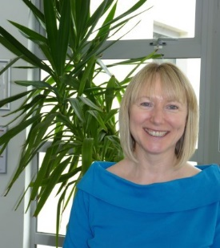
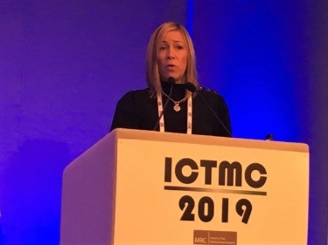

Find us on the web! www.nmahp-ru.ac.uk @NMAHPRu

Contact NMAHP-RU

GCU
nmahpruadmin@gcu.ac.uk 0141 331 8100
Govan Mbeki Building, Glasgow Caledonian University, Cowcaddens Road, Glasgow, G4 0BA

Stirling
nmahp.ru@stir.ac.uk 01786 466341
Unit 13 Scion House, University of
Stirling Innovation Park, Stirling, FK9 4NF

Recent publications
Booth, J., Macaulay, L., Hagen, S., Lawrence, M., Mason, H., McClurg, D., O'Dolan, C., Skelton, D., Aucott, L., Cotton, S., Goodman, C., Harari, D., Lownes, A., Maclennan, G., Norrie, J., Norton, C., Surr, C. and Treweek, S. (2019) ELECtric Tibial nerve stimulation to Reduce Incontinence in Care Homes: protocol for the ELECTRIC randomised trial. Trials, 20, pp. 723. Https://doi.org/10.1186/s13063-019-3723-7
Chandler, A., Whittaker, A., Cunningham-Burley, S., Elliot, L., Midgley, P. and Cooper, S. (2020) Diagnosing Uncertainty, Producing Neonatal Abstinence Syndrome (NAS). Sociology of Health and Illness (e-Pub Ahead of Print) Https://doi.org/10.1111/1467-9566.13000
Clarke, J., Ingram, J., Johnson, D., Thomson, G., Tricky, H., Dombrowski, S., Sitch, A., Dykes, F., Feltham, M., MacArthur, C., Roberts, T., Hoddinott, P. and Jolly, K. (2019) The Assets-based infant feeding help Before and After birth (ABA) intervention for improving breastfeeding initiation and continuation: feasibility study results. Maternal & Child Nutrition (e-Pub Ahead of Print) Https://doi.org/10.1111/mcn.12907
Croot, E., O'Cathain, A., Sworn, K., Yardley, L., Turner, K., Duncan, E. and Hoddinott, P. (2019) Developing interventions to improve health: a systematic mapping review of international practice between 2015 and 2016. Pilot and Feasibility Studies, 5. Https://doi.org/10.1186/s40814-019-
0512-8
Macintyre, A., Torrens, C., Campbell, P., Maxwell, M., Pollock, A., Biggs, H., Woodhouse, A., Williams, J. and McLean, J. (2019) Socioeconomic inequalities and the equity impact of population-level interventions for adolescent health: an overview of systematic reviews. Public Health (e-Pub Ahead of Print) Https://doi.org/10.1016/j.Puhe.2019.11.008
Youssef, N., Best, C., Mackay, W., Hagen, S. and Shepherd, A. (2019) Psychometric Properties of the Arabic Version of the International Consultation on Incontinence Questionnaire on Long-Term Catheter Quality Of Life. International Journal of Nursing Practice (e-Pub Ahead of Print)
Https://doi.org/10.1111/ijn.12807

The full list of papers is available at: https://www.nmahp-ru.ac.uk/research/publications/

Directors Blog:
Welcome to the first Newsletter of 2020, a year which may begin to illuminate significant changes for health based research in the UK as regards participation in EU funded research. This is at a time when the NMAHP Research Unit is poised to expand its EU and international collaborations with
applications in preparation or pending funding decisions. This month also saw the launch, in Cork, of a new EU Horizon 2020 project involving the Unit – MENTUPP (Mental Health Promotion and Intervention in Occupational Settings) which is a 4 year project involving 17 partners. The primary aim of MENTUPP is to improve mental health in the workplace by developing, implementing and evaluating a multi- level intervention targeting mental health problems in staff employed in small and medium sized enterprises (SMEs) across construction, health and ICT sectors. A secondary aim is to reduce depression and suicidal behaviour. The health and wellbeing of the healthcare workforce has already been recognised as a significant challenge to the NHS in Scotland and beyond and the NMAHP-RU is delighted to
be conducting work which will contribute to addressing this challenge.
Best Wishes, Margaret Maxwell

