Innovation in NMAHP Interventions

The remit of the Innovation in NMAHP Interventions (INI) programme (Figure
1) is to develop and evaluate innovative NMAHP interventions, contributing to the evidence base to ultimately improve patient care and outcomes.

The methodological work of the programme underpins the development and evidence stages with robust and efficient processes. Progressive methodological approaches are used in the development and modelling of complex innovative interventions within NMAHP clinical settings. Interventions are designed and tested to maximise adherence to interventions, so as to optimise impact.
Strategic aims:

Figure 1: Innovation in NMAHP Interventions programme

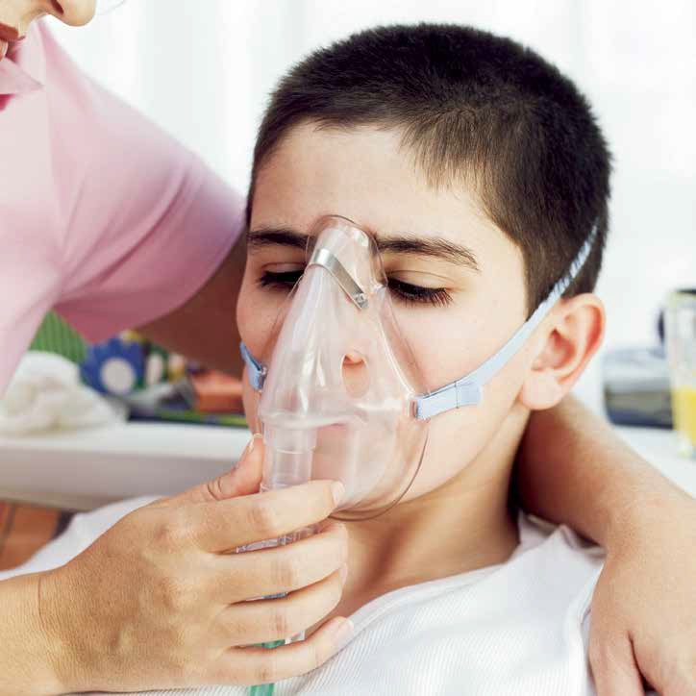
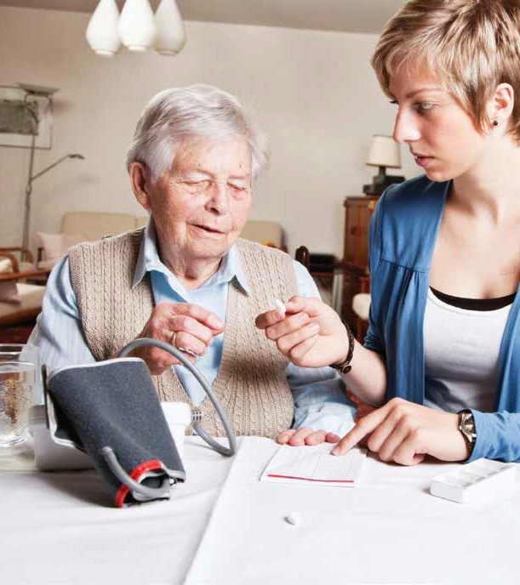
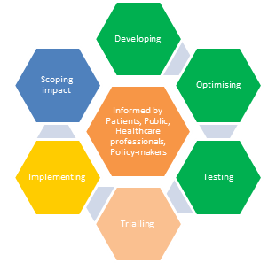
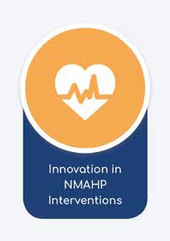
- To undertake research (primary, secondary and implementation research) which addresses the development, design and effectiveness of NMAHP interventions, with a focus on innovation and digital solutions to achieve health gain.
Nursing, Midwifery and Allied Health Professions Research Unit
- To undertake methodological research which improves our ability to successfully and efficiently evaluate NMAHP interventions and to maximise likely impact.
- To engage in cross-programme working with the NMAHP RU’s Transforming Care Delivery and Maximising Data Usage in NMAHP Research programmes to enhance our research in the phases of intervention development and translation of evidence relating to effective interventions.

Achieving impact:
The programme capitalises on commissioned calls, priority setting information and responds to national policy agendas to prioritise its focus.
The following criteria are used to ensure maximum impact:
- selecting high impact areas
- within NMAHP domains
- with scope for innovation
- with potential for future implementation
- with high patient priority
- relevant to policy
- value for money
See inside pages for study examples.

Pilot Studies of NMAHP Innovations – building the foundation for trials
Game of Stones
Obesity rates amongst Scottish adults are increasing, with important consequences for their health. However, men rarely participate in weight loss programmes. The Game of Stones study looks at whether two interventions which show promise can help obese men lose weight and keep it off. Text messages and incentives are being tested to see if they could reach large numbers, including men who don’t use health services. This feasibility study for a full trial involves men with obesity and The Men’s Health Forum to help us find the best ways to deliver the interventions and design the research.
SKIP-IT
Smoking is a serious cause of preventable harm to mothers and babies. SKIP-IT is a pilot and feasibility study of a narrative text messaging intervention designed to support pregnant women who are looking to give up smoking. The story-based text messages are delivered to women from 14 weeks pregnancy to 6 weeks post-birth and are delivered alongside the ‘usual care’ given by smoking cessation services in their health board. SKIP-IT is currently being trialled in 5 health boards in Scotland and one in England, with half the women allocated to receive the intervention and half in the control.
SCooP
Cystic fibrosis (CF) is an inherited, life-threatening disorder of the lungs and digestive system affecting approximately 1 in 2,500 children in the UK. Chest physiotherapy is a major component in the respiratory management of CF to help prevent lung damage. Adherence in young children is important because damage occurs rapidly and can be irreversible. However, only 50% of parents and young children adhere to their recommended regimen. Interventions to address this significant problem are lacking. The SCooP project involved the development and testing of an audio-visual intervention to increase physiotherapy adherence among 0-8 year olds. The project was funded by the Chief Scientist’s Office and the Cystic Fibrosis Trust. A follow-on trial of the intervention is in development.
Trials of NMAHP Innovations – providing definitive evidence for practice
OPAL
Intensive pelvic floor muscle training (PFMT) may be more effective than basic PFMT for female stress and mixed urinary incontinence (UI), but how best to intensify PFMT, to optimise benefit, is unclear. Adding biofeedback is one option which shows potential but the research evidence is unclear. We address this uncertainty in the OPAL multicentre trial by investigating the clinical and cost-effectiveness of basic PFMT versus biofeedback- mediated intensive PFMT. We hypothesise biofeedback will increase PFMT adherence and effectiveness, leading to greater reductions in UI at 2 years.
STARTUP
Parkinson’s disease (PD) is characterised predominantly by the motor complaints of bradykinesia, rigidity, rest tremor and gait disturbances. However non-motor symptoms (NMS) are also a common accompaniment including lower urinary tract symptoms (LUTS). These LUTS are an important cause for morbidity and have an immense impact on early institutionalization and health-related costs. Previous studies have demonstrated that the non-invasive “transcutaneous tibial nerve stimulation” (TTNS) method holds promise as a safe and acceptable option in the treatment of LUTS and subsequently quality of life, in the non-neurogenic population. However, efficacy of this treatment type has yet to be determined for patients with Parkinson’s Disease. We address this lack of efficacy in the STARTUP trial by assessing TTNS as a therapeutic option for LUTS in people with Parkinson’s, including a cost-effective analysis. We hypothesise that TTNS will lead to improved LUTS and quality of life in people with Parkinson’s.
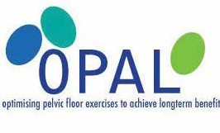
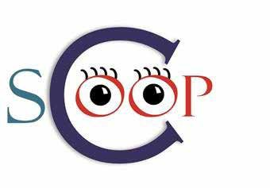
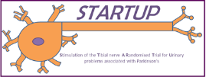

TOPSY
Pelvic organ prolapse is a common condition that often leads to women having symptoms that interrupt their day to day life. One treatment that some women receive for pelvic organ prolapse is a vaginal pessary. However, it is not clear how to support women once their pessary is in place. One option is that women attend an appointment approximately every four to six months to have their pessary changed: this is called standard pessary care. Another option is that women are taught how to remove and re-insert their pessary at home: this is called pessary self-management. At the moment there is no evidence to tell us which of these is better for women. Therefore the TOPSY trial aims to compare standard pessary care with pessary self-management to find out which is better at improving women’s quality of life when they are using a vaginal pessary for treatment of pelvic organ prolapse.
MOWOOT
Constipation is common in people with multiple sclerosis (MS) affecting patients’ quality of life. Despite this, current treatment options are limited, poorly evaluated and complex. Abdominal massage is one possible treatment option which has been shown to reduce the symptoms of constipation. A recent trial looked at the effects of self-administered abdominal massage on constipation in people with MS, and reported an increase in the number of defecations per week and improved quality of life. However, this type of massage can be tiring to undertake meaning that health care professionals or carers may have to administer the massage which has cost and time implications. A device called MOWOOT has been designed to reproduce the effects of the abdominal massage and the aim of the MOWOOT study is to measure the effect the device has on the number of complete bowel movements per week for people presenting with MS.
Pathway to Impact
POPPY
One example that demonstrates the benefits of taking a long-term focused approach from inception of an idea through to clinical implementation phase is that of the Pelvic Organ Prolapse portfolio of work. The workstream started with a Cochrane review of prolapse management focusing on Pelvic Floor Muscle Training (PFMT) published in 2004, followed by further Cochrane reviews in tandem with a UK survey, published in 2004, of practice amongst >500 women’s health physiotherapists. The survey and review findings informed a feasibility study, which in turn led to a definitive international multicentre trial of PFMT for prolapse, POPPY, carried out between 2007-2011. A follow-up survey of practice assessed the impact of the evidence generated, and an implementation study (PROPEL) is underway exploring different models of translating the evidence into clinical practice.
Methodological PhD studies
Optimising complex health interventions
NMAHP interventions are usually complex in nature, with multicentre interacting components, requiring a distinct development phase prior to trial. The aims of this study include identification and developing a taxonomy of modelling techniques and processes currently adopted in the development of complex interventions; to gain researcher accounts regarding experience and associated pros and cons of different techniques; to attempt to link the appropriateness of different modelling approaches to different types of complex health interventions, based on the elements and data gathered to develop the taxonomy; to assess some of the gaps in the evidence base on the validity and usefulness of varied processes identified.
Recruitment to stroke rehabilitation trials
Recruitment to clinical trials is notoriously difficult. Often trials under recruit, have to seek further funds, and are extended or terminated due to poor recruitment. The ability of research to accurately assess intervention efficiency is dependent upon successful recruitment. A trial has to recruit a specific number of participants for statistical power but also be representative of the overall targeted population. This study aims to: (1) establish recruitment rates for the past 10 years of stroke rehabilitation intervention trials, (2) determine if there are any specific trial features that appear to affect these rates, (3) consider how well trials represent the overall population of stroke survivors,
(4) approach experienced stroke rehabilitation researchers to ask what contributed to successful recruitment, (5) approach stroke survivors to determine how best to support them during research participation. It will provide information for stroke rehabilitation researchers to assist them when planning projects, to properly account for the resources, time, and trial features required for successful recruitment.

NMAHP Trialists

The Unit has developed a critical mass of NMAHP Trialists to support methodological developments in randomised controlled trials, including economic evaluation, of complex interventions relevant to the nursing, midwifery or allied health professions. Our trials are supported by the:
- Trial Management Group: consists of highly experienced trial managers and researchers who share

knowledge, and support research staff in all aspects of trial design and management.
- Quantitative Methods Group: consists of experienced statisticians and data analysts

Qualitative Trialists: researchers who use their qualitative skills to support the development of interventions; understanding of trial implementation; and understanding of trial outcomes.

Selected methodological publications:
- Cook, J., Elders, A., Boachie, C., Bassinga, T., Fraser, C., Altman, D., Boutron, I., Ramsay, C. and MacLennan, G. (2015) A systematic review of the use of an expertise-based randomised controlled trial design. Trials, 16, pp. 241. Doi: https:// doi.org/10.1186/s13063-015-0739-5
- Levati, S., Campbell, P., Frost, R., Dougall, N., Wells, M., Donaldson, C. and Hagen, S. (2016) Optimisation of complex health interventions prior to a randomised controlled trial: a scoping review of strategies used. Pilot and Feasibility Studies, 2, pp. 17. Doi: https://doi.org/10.1186/s40814-016-0058-y
- Murray, J., Williams, B., Hoskins, G., Skar, S., McGhee, J., Treweek, S., Sniehotta, F., Sheikh, A., Brown, G., Hagen, S., Cameron, L., Jones, C. and Gauld, D. (2016) A theory-informed approach to developing visually mediated interventions to change behaviour using an asthma and physical activity intervention exemplar. Pilot and Feasibility Studies, 2(1), p.46. Doi: https://doi.org/10.1186/s40814-016-0091-x
- O’Cathain, A., Hoddinott, P., Lewin, S., Thomas, K., Young, B., Adamson, J., Jansen, Y., Mills, N., Moore, G. and Donovan,
J. (2015) Maximising the impact of qualitative research in feasibility studies for randomised controlled trials: guidance for
researchers. Trials, 16 (Supplement 2), pp. 088. Abstract only from Doi: https://doi.org/10.1186/1745-6215-16-S2-O88

Unit background:
The Nursing, Midwifery and Allied Health Professions Research Unit (NMAHP RU) is a multidisciplinary national research unit, funded by the Scottish Government Health Directorate Chief Scientist Office. It has academic bases within Glasgow Caledonian University and the University of Stirling.
Research programmes:
NMAHP RU focuses its activity on three strong programmes of research that will impact on NMAHP practice and benefit patient and population health. These are: Innovation in NMAHP Interventions, Transforming Care Delivery and Maximising Data Usage in NMAHP Research. This leaflet provides information on the Innovation in NMAHP Interventions Programme, led by Professor Suzanne Hagen.

Find out more:

You can find further information on all of our research programmes, recent research projects, publications
and keep up to date with our latest news, on our website: www.nmahp-ru.ac.uk
www.nmahp-ru.ac.uk

Twitter: @nmahpru
nmahpruadmin@gcu.ac.uk
nmahp.ru@stir.ac.uk
0141 331 8100
01786 466341
Contact details:
General contact Stirling: General contact GCU:
Pathfoot Building 6th floor Govan Mbeki Building University of Stirling Glasgow Caledonian University Stirling Cowcaddens Road
FK9 4LA Glasgow
G4 0BA

